**SEHH2240 Database Systems**



**CC Food Delivery Platform**

Prepared by Class 201 Group B4

20077067A CHO Shing Yin

20065935A KWOK Chun Wing

20193240A WONG Cho Hin

20053334A WONG Tin Yau

**Contents**

1. Idea of Creating a Food Delivery Platform 4

2. Introduction of Food Delivery Platform 4

3. Background Description of Business Relationships Between Users 5

4. Data dictionary 7

5. Conceptual design 8

Entity Relationship Modeling and Normalization 8

6. Dependency Diagram 10

a. Business 10

b. Client 10

c. Event 10

d. Food 10

e. Food Truck 11

f. Order 11

g. Order_Food 11

h. Staff 12

i. Admin 12

j. AdminLevel 12

7. Logic design 13

a. Business 13

b. Client 13

c. Event 13

d. Food 14

e. Food_Truck 14

f. Order 14

g. Order_Food 15

h. Staff 15

i. Admin 15

j. AdminLevel 16

8. Data Security Control 17

9. Implementation Details 19

Flowcharts of the Program 19

i. Flowcharts for customers 19

ii. Flowcharts for business partners 19

10. Security measure of our database 25

a. Filter 25

11. User interface and Form design 27

a. For Business Partners 27

i. The user interface for business partners. 27

ii. The login screen for business partners 27

iii. The Business Registration Form 28

iv. Password Change Screen 28

v. Interface for Business modify record 29

vi. Interface after login 29

b. For Clients 31

i. Interface for clients 31

ii. Login screen for client 31

iii. Form for client edit data 32

iv. Form for order food 32

c. For Staff 34

i. Basic UI for Staff 34

ii. Login Screen For Staff 34

iii. Password Changing Form 35

iv. Staff Registration Form 35

v. Interface for staff after login 35

vi. Form for staff to edit their data 36

12. VBA 37

a. VBA for Business 37

b. VBA for Client 41

c. For all of the users 51

vii. Menu 51

13. Report design 58

a. Food_Rank_In_Total_Report: 58

b. Money_Flow_In_Total_Report 59

c. Food_Rank_In_Total Report (By Type) 60

d. Business_Rank_In_Total 61

e. Food_Rank_For_Specific_Food 62

14. Work Distribution List 64

15. Conclusion 65

16. Reference 66

# Idea of Creating a Food Delivery Platform

People are increasingly seeking convenience in their daily lives. Due to the COVID-19 epidemic, people try to avoid going out. However, eating is a must for the public. When people do not want to go out and cook, they must use food delivery services. We anticipated that the demand for food delivery services will increase, so we decided to open a food delivery platform.

# Introduction of Food Delivery Platform

Food delivery platform is a database system which aims at storing different data that will be used during food delivery. Via searching this database system, our staff will be able to acknowledge the detail of the order. They will be able to meet customer’s requirements and deliver the food correctly Also, customers can track which staff is responsible for their order. Customers can contact the staff with the phone number provided in the UI.

# Background Description of Business Relationships Between Users

For this system, managers of CCFood and business partners of CCFood will be the user. The end-users of CCFood system will be clients, staff and restaurants.

For the client of CCFood. They can choose and order food from our platform. We provide many kinds of food. Different food will provide by different restaurant. If client have any special requirement with the food, they can point out and let our stuff to fulfill.

For the staff of CCFood, they can check the order from the platform. Customers' address can be checked from the database and they can deliver food to the right location.

For food, customer can choose and order the food by our food rank.

For the order, each order contain one or many foods ordered by customer, each order will be delivered by one of the staff of CCFood.

For the business partners, they can check how many orders they have taken from our platform and check their turnover. Let them know how many order and sales they gain from our platform.

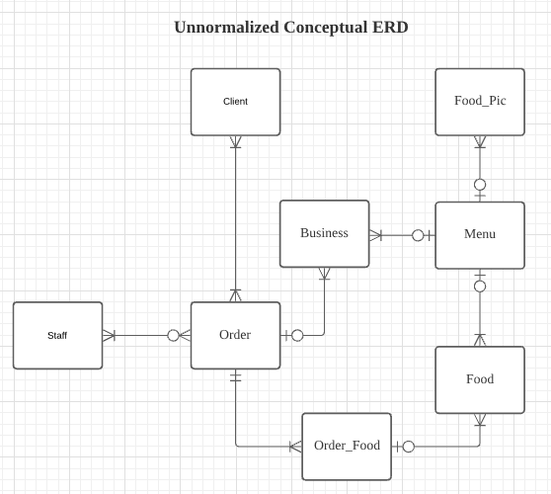

As this is only the concept of delivery system, more function will be changed on and database will be normalized thought 3NF in the future.

# Data dictionary

Business (BID, BName, BPassword, BPhone, BEmail, BAddress1, BAddress2, BAddress3)

Client (CID, CName, CPassword, CPhone, CEmail, CAddress1, CAddress2, CAddress3)

Event (EID, BID, ECode, EStartDate, EEndDate, EMessage, EDiscount)

Food (FID, FName, FType, FPrice, FSize, FPic, BID)

Food_Truck (CID, FID, FQuantity)

Order (OID, CID, SID, OTime, OTime_Search, O_Message)

Order_Food (OID, FID, OFQuantity)

Staff (SID, SName, SPassword, SPhone, SEmail)

Admin (AID, AName, APassword, APhone, ALID)

AdminLevel (ALID, ALDescription)

# Conceptual design

## Entity Relationship Modeling and Normalization

Base on the background description of business relationships between Users relationship above. we design a more complete ERD and add more function in it.

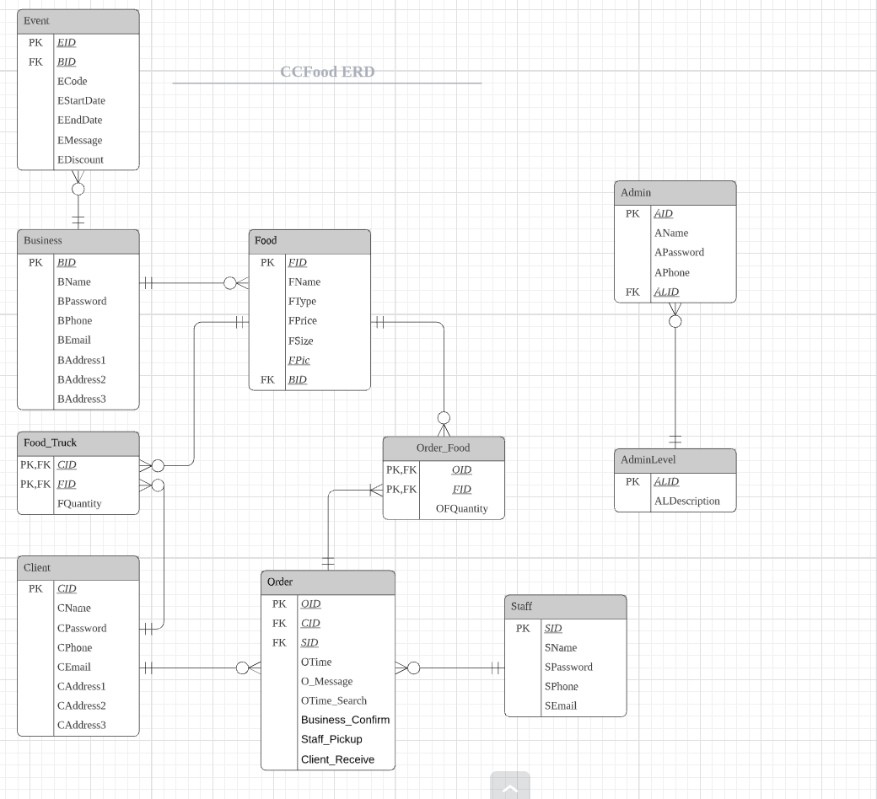

In this ERD, some of the function are added and many M:N relationships are broken down in 1:M and M:1 relationship.

For the entity Food and Order, a composite entity order food are added to resolve the M:N relationship between Food and Order. For this table, O_ID and F_ID are used as a composite key. Since each order may have many or one Order_Food only, Order and Order_Food are in 1:M relationship Food and Order_Food are in 1 to 0-or-many relationship since the food are popular and order by many clients or may not order by any clients.

For the entity Client and Food, a composite entity Food_Truck are added to resolve the M:N relationship between Food and Client. For this table. C_ID and F_ID are used as a Composite key. Food and Food_Truck are in 1 to 0-or-many relationship since Food_Truck can store many or none of specific kind of food. Food_Truck and Client are in 0-or-many to 1 relationship since there can be no food truck or many food trucks to provide food to a client.

For the entity Business, since our company will held different events to attract more customers, the entity Event are added to record the different event at specific date. Such as we will have 50% off at 20/4.

# Dependency Diagram

## Business

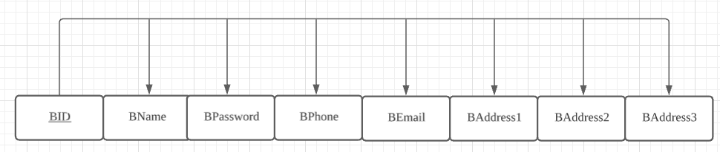

Relational Schema: Business (BID, BName, BPassword, BPhone, BEmail, BAddress1, BAddress2, BAddress3)

## Client

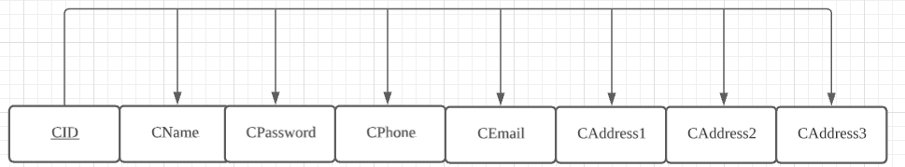

Relational Schema: Client (CID, CName, CPassword, CPhone, CEmail, CAddress1, CAddress2, CAddress3)

## Event

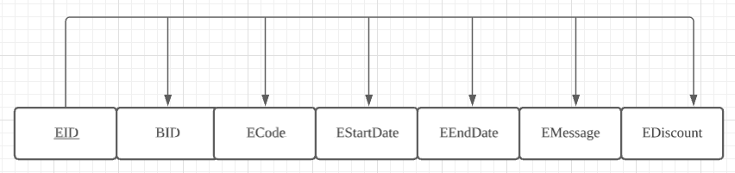

Relational Schema: Event (EID, BID#, ECode, EStartDate, EEndDate, EMassage, EDiscount)

## Food

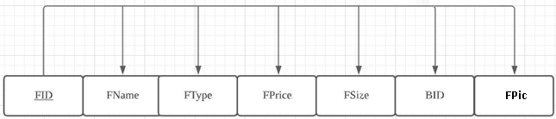

Relational Schema: Food (FID, FName, FType , FPrice, FSize, BID#, FPic)

## Food Truck

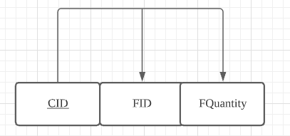

Relational Schema: Food_Truck (CID, FID#, FQuantity)

## Order

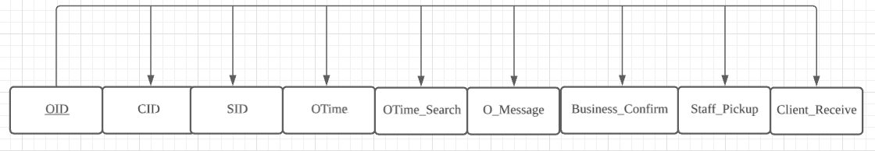

Relational Schema: Order (OID, CID#, SID#, OTime, OTime_Search, O_Message, Business_Confirm, Staff_Pickup, Client_Receive)

## Order_Food

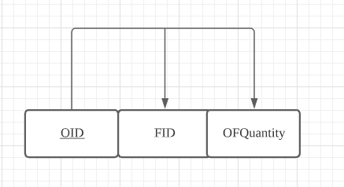

Relational Scheme: Order_Food (OID, FID#, OFQuantity)

## Staff

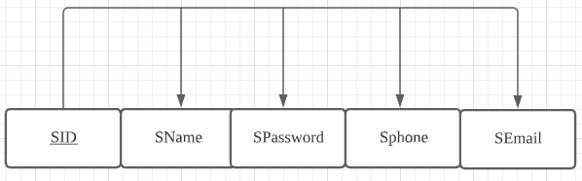

Relational Scheme: Staff (SID, SName, SPassword, Sphone, SEmail)

## Admin

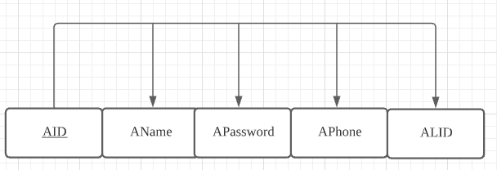

Relational Scheme: Admin (AID, AName, APassword, APhone, ALID#)

## AdminLevel

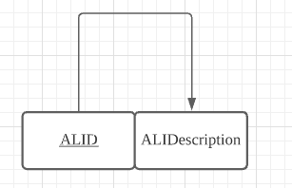

Relational Scheme: AdminLevel (ALID, ALIDescription )

# Logic design

The following tables and attributes are all implemented within the environment of Microsoft Access.

## Business

This table stores the information of our business partners for registration.

|  |  |  |  |  |  |
| --- | --- | --- | --- | --- | --- |
| Business | | | | | |
|  | Attribute | Data Type | Description | Size | Rule |
| PK | BID | AutoNumber | Business ID |  |  |
|  | BName | Short Text | Business Name |  | Not Null |
|  | BPassword | Long Text | Business Password | 576 | Not Null |
|  | BPhone | Number | Business Phone | 8 | * |
|  | BEmail | Long Text | Business Email | 50 |  |
|  | BAddress1 | Long Text | Business Address Area |  | Not Null |
|  | BAddress2 | Long Text | Business Address Street |  |  |
|  | BAddress3 | Long Text | Business Address Room |  |  |

## Client

This table stores the personal information of our customers for registration.

|  |  |  |  |  |  |
| --- | --- | --- | --- | --- | --- |
| Client | | | | | |
|  | Attribute | Data Type | Description | Size | Rule |
| PK | CID | AutoNumber | Client ID |  |  |
|  | CName | Short Text | Client Name |  | Not Null |
|  | CPassword | Long Text | Client Password | 576 | Not Null |
|  | CPhone | Number | Client Phone | 8 | * |
|  | CEmail | Long Text | Client Email | 50 |  |
|  | CAddress1 | Long Text | Client Address Area |  |  |
|  | CAddress2 | Long Text | Client Address Street |  |  |
|  | CAddress3 | Long Text | Client Address Room |  |  |

## Event

This table stores the details of events hold by different business partners.

|  |  |  |  |  |  |
| --- | --- | --- | --- | --- | --- |
| Event | | | | | |
|  | Attribute | Data Type | Description | Size | Rule |
| PK | EID | AutoNumber | Event ID |  |  |
| FK | BID | AutoNumber | Business ID |  |  |
|  | ECode | Long Text | Event Code |  | Not Null |
|  | EStartDate | Number | Event Start Date |  |  |
|  | EEndDate | Long Text | Event End Date |  |  |
|  | EMessage | Long Text | Event Description |  |  |
|  | EDiscount | Long Text | Event Discount |  |  |

## Food

This table stores the details of different foods.

|  |  |  |  |  |  |
| --- | --- | --- | --- | --- | --- |
| Food | | | | | |
|  | Attribute | Data Type | Description | Size | Rule |
| PK | FID | AutoNumber | Food ID |  |  |
|  | FName | Long Text | Food Name |  | Not Null |
|  | FType | Long Text | Food Type |  |  |
|  | FPrice | Number | Food Price |  |  |
|  | FSize | Long Text | Food Size |  |  |
| FK | BID | AutoNumber | Business ID |  |  |
|  | FPic | Attachment | Food Picture |  |  |

## Food_Truck

This table stores the food items that customers selected temporarily.

|  |  |  |  |  |  |
| --- | --- | --- | --- | --- | --- |
| Food_Truck | | | | | |
|  | Attribute | Data Type | Description | Size | Rule |
| PK | CID | Number | Client ID |  |  |
| FK | FID | Number | Food ID |  |  |
|  | FQuantity | Number | Food Number |  |  |

## Order

This table acts as a receipt which mainly stores the date and time of the order being processed successfully, types, quantity and the price of food, total cost and an order ID.

|  |  |  |  |  |  |
| --- | --- | --- | --- | --- | --- |
| Order | | | | | |
|  | Attribute | Data Type | Description | Size | Rule |
| PK | OID | AutoNumber | Order ID |  |  |
| FK | CID | Number | Client ID |  |  |
| FK | SID | Number | Staff ID |  |  |
|  | OTime | Date/Time | Order Time in hour |  |  |
|  | OTime_Search | Date/Time | Order Time in day |  |  |
|  | O_Message | Long Text | Order Message |  |  |
|  | Business_Confirm | Yes/No | Confirm finished making by Restaurant |  |  |
|  | Staff_Pickup | Yes/No | Confirm Picked up by Staff |  |  |
|  | Client_Receive | Yes/No | Confirm received by Client |  |  |

## Order_Food

This Table acts as a receipt for the restaurants to know what their customers have ordered. The order ID is for verifying with our staff by confirming the same order ID received by both business partners and our staff.

|  |  |  |  |  |  |
| --- | --- | --- | --- | --- | --- |
| Order_Food | | | | | |
|  | Attribute | Data Type | Description | Size | Rule |
| PK | OID | Number | Order ID |  |  |
| FK | FID | Number | Food ID |  |  |
|  | OFQuantity | Number | Quantity |  |  |

## Staff

This table stores the personal information of our staff.

|  |  |  |  |  |  |
| --- | --- | --- | --- | --- | --- |
| Staff | | | | | |
|  | Attribute | Data Type | Description | Size | Rule |
| PK | SID | AutoNumber | Staff ID |  |  |
|  | SName | Short Text | Staff Name |  | Not Null |
|  | SPassword | Long Text | Staff Password | 576 | Not Null |
|  | SPhone | Number | Staff Phone number | 8 | * |
|  | SEmail | Long Text | Staff E-mail | 50 |  |

## Admin

This table stores the personal information of the database administrators.

|  |  |  |  |  |  |
| --- | --- | --- | --- | --- | --- |
| Admin | | | | | |
|  | Attribute | Data Type | Description | Size | Rule |
| PK | AID | AutoNumber | Admin ID |  |  |
|  | AName | Long Text | Admin Name |  | Not Null |
|  | APassword | Long Text | Admin Password | 576 | Not Null |
|  | APhone | Number | Admin Phone number | 8 | * |
| FK | ALID | AutoNumber | Admin Level ID |  | Not Null |

## AdminLevel

This table lists out the level of the administrators with descriptions.

|  |  |  |  |  |  |
| --- | --- | --- | --- | --- | --- |
| AdminLevel | | | | | |
|  | Attribute | Data Type | Description | Size | Rule |
| PK | ALID | AutoNumber | Admin Level ID |  |  |
|  | ALDescription | Long Text | Admin Level description |  | Not Null |

*:Number have be inside the range 20000000-39999999,50000000-69999999,90000000-99999999 due to Hong Kong’s phone number starts at 2,3,5,6,9.

# Data Security Control

1. **Password Security**

Uppercase and lowercase letters, numbers and symbols are required to be included in password to increase the security level. Besides, we use type check, length check or field check instead of some simple checking to ensure the security as well.

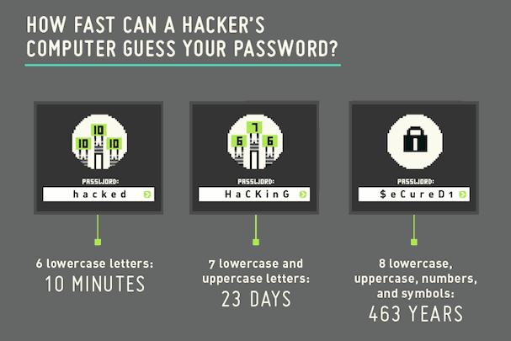However, if the password is stored in an insecure way, these restrictions would be invalid. In SQL, a password is usually stored in the database, so we need to be very careful when storing the password. But the password is stored in the table in plain text which is vulnerable to attacks. If an attacker accesses the database, he can steal the password of clients or even the administrators. Therefore, the password in the database should be encrypted well and made as complicated as possible to avoid being illegally decrypted. 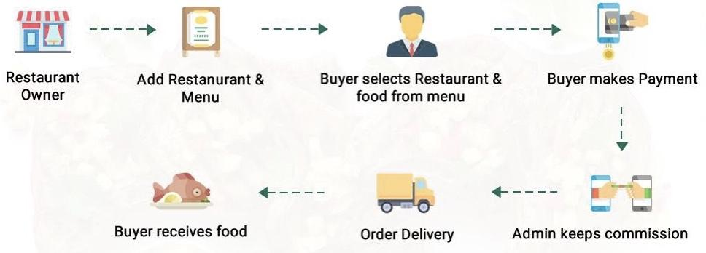

Users are required to input password during the making payment process in which password is necessary to be encrypted.

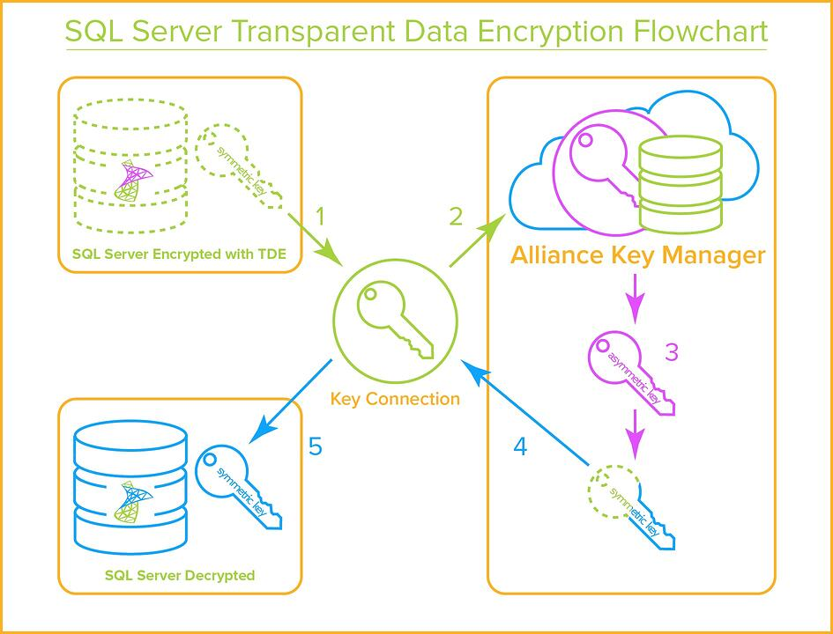1. The SQL server requests the Data Encryption Key (DEK) to be decrypted by the Key Encryption Key (KEK).

2. The key connection sends a decryption request to Alliance Key Manager (AKM).

3. AKM decryption and KEK's DEK.

4. AKM sends the decrypted DEK to the Key connection.

5.Key connection sends the decrypted DEK to SQL Server so that the database can be decrypted.

This Process can significantly ensure the security by using SHA1(SHA-256 XOR Salt) method to encrypt.

Screenshot for password encryption.

# Implementation Details

## Flowcharts of the Program

### Flowcharts for customers

|  |  |
| --- | --- |
| Program Procedures | Description |
| 1 | Customers would register by filling their personal information through a program. |
| 2 | Personal information of customers will be validated and stored in the database system. |
| 3 | Customers can select their wanted items from different registered shops by using different functions (food rank, types of food). |
| 4 | The selected items will be stored in the Food truck temporarily such that customers can double check what they have selected. |
| 5 | Customers can pay the bill through online payment. |
| 6 | Customers will receive a digital receipt with customers’ name, time and date, items ordered, price of each item and total cost. |
| 7 | Customers can wait for their ordered food. |

### Flowcharts for business partners

|  |  |
| --- | --- |
| Program Procedures | Description |
| 1 | Business partners would register by filling their personal information through a program. |
| 2 | Information of business partners will be validated and stored in the database system. |
| 3 | Business partners can input their products with pictures to the program for customers to select. |
| 4 | Once there is an order on their own restaurant, they will receive a receipt showing the name and quantity of food with the order ID. |
| 5 | Business partners can verify our staff by confirming the same order ID received by both business partners and our staff. |

Queries Design

|  |  |  |  |
| --- | --- | --- | --- |
| Target | Query Name | SQL | Description |
| Business partner | 1.Business rank in total | SELECT b.BName, SUM(of.OFQuantity) AS Quantity  FROM Food AS f, Order_Food AS [of], Business AS b  WHERE of.FID = f.FID AND f.BID = b.BID  GROUP BY b.BName  ORDER BY SUM(of.OFQuantity) DESC; | Show out which Business partner are most popular and the quantity of food ordered. |
| 2.Business rank in total (Top5) | SELECT TOP 5 b.BName, SUM(of.OFQuantity) AS Quantity  FROM Food AS f, Order_Food AS [of], Business AS b  WHERE of.FID = f.FID AND f.BID = b.BID  GROUP BY b.BName  ORDER BY SUM(of.OFQuantity) DESC; | Show out top 5 Business partner which are most popular and the quantity of food ordered. |
| Client | 1.Food rank for hamburger | SELECT b.BName, f.FName AS Name, f.FPrice AS Price, SUM(of.OFQuantity) AS Quantity  FROM Food AS f, Order_Food AS [of], Business AS b  WHERE of.FID = f.FID AND f.BID = b.BID AND f.FType = "Hamburger"  GROUP BY b.BName, f.FName, f.FSize, f.FPrice, f.FSize  ORDER BY SUM(of.OFQuantity) DESC; | Show out which business partner having highest number of sales of hamburger so client can refer this rank to order. |
| 2.Food rank for noodles | SELECT b.BName, f.FName AS Name, f.FPrice AS Price, SUM(of.OFQuantity) AS Quantity  FROM Food AS f, Order_Food AS [of], Business AS b  WHERE of.FID = f.FID AND f.BID = b.BID AND f.FType = "Noodles"  GROUP BY b.BName, f.FName, f.FSize, f.FPrice, f.FSize  ORDER BY SUM(of.OFQuantity) DESC; | Show out which business partner having highest number of sales of noodles so client can refer this rank to order. |
| 3.Food rank for rice | SELECT b.BName, f.FName AS Name, f.FPrice AS Price, SUM(of.OFQuantity) AS Quantity  FROM Food AS f, Order_Food AS [of], Business AS b  WHERE of.FID = f.FID AND f.BID = b.BID AND f.FType = "Rice"  GROUP BY b.BName, f.FName, f.FSize, f.FPrice, f.FSize  ORDER BY SUM(of.OFQuantity) DESC; | Show out which business partner having highest amount of sales of rice so client can refer this rank to order. |
| 4.Food rank for snacks | SELECT b.BName, f.FName AS Name, f.FPrice AS Price, SUM(of.OFQuantity) AS Quantity  FROM Food AS f, Order_Food AS [of], Business AS b  WHERE of.FID = f.FID AND f.BID = b.BID AND f.FType = "Snacks"  GROUP BY b.BName, f.FName, f.FSize, f.FPrice, f.FSize  ORDER BY SUM(of.OFQuantity) DESC; | Show out which business partner having highest amount of sales of snacks so client can refer this rank to order. |
| 5.Food rank for spaghetti | SELECT b.BName, f.FName AS Name, f.FPrice AS Price, SUM(of.OFQuantity) AS Quantity  FROM Food AS f, Order_Food AS [of], Business AS b  WHERE of.FID = f.FID AND f.BID = b.BID AND f.FType = "Spaghetti"  GROUP BY b.BName, f.FName, f.FSize, f.FPrice, f.FSize  ORDER BY SUM(of.OFQuantity) DESC; | Show out which business partner having highest amount of sales of spaghetti so client can refer this rank to order. |
| 6.Food rank in last year(2021) | SELECT b.BName, f.FName AS Name, f.FPrice AS Price, SUM(of.OFQuantity) AS Quantity  FROM Food AS f, Order_Food AS [of], Business AS b, [Order] AS o  WHERE of.FID = f.FID AND f.BID = b.BID AND of.OID=[o].[OID] AND Year([o].[OTime_Search])=2021  GROUP BY b.BName, f.FName, f.FSize, f.FPrice, f.FSize  ORDER BY SUM(of.OFQuantity) DESC; | Display the data of highest sales of food sold out last year,such as BName, name,price,and quantity for client reference. |
| 7.Food rank in total | SELECT b.BName, SUM(of.OFQuantity) AS Quantity  FROM Food AS f, Order_Food AS [of], Business AS b  WHERE of.FID = f.FID AND f.BID = b.BID  GROUP BY b.BName  ORDER BY SUM(of.OFQuantity) DESC; | Display the data of highest sales of food sold out,such as BName, name,price,and quantity for client reference. |
| 8.Food rank in total (TOP5) | SELECT TOP 5 b.BName, f.FName AS Name, f.FPrice AS Price, SUM(of.OFQuantity) AS Quantity  FROM Food AS f, Order_Food AS [of], Business AS b  WHERE of.FID = f.FID AND f.BID = b.BID  GROUP BY b.BName, f.FName, f.FSize, f.FPrice, f.FSize  ORDER BY SUM(of.OFQuantity) DESC; | Display the data of TOP 5 sales of food sold out,such as BName, name,price,and quantity for client reference. |
| CCFood | 1.Food Truck | SELECT Food.FName, Food.FSize, Food.FPrice, SUM(Food_truck.FQuantity) AS Quantity  FROM Client, Food_Truck, Food  WHERE Client.CID = Food_truck.CID AND Food_Truck.FID = Food.FID  GROUP BY Food.FName, Food.FSize, Food.FPrice  ORDER BY SUM(Food_truck.FQuantity) DESC; | Display the data of food in food truck such as foodname,foodsize(the place that food consuming),food price and the quantity. |
| 2.Money flow in last month | SELECT f.FName AS Name, SUM(of.OFQuantity) AS Quantity, SUM(of.OFQuantity* f.FPrice) AS [Total Flow]  FROM Food AS f, Order_Food AS [of], [Order] AS o  WHERE of.FID = f.FID AND of.OID = o.OID AND year(o.OTime_Search) = 2021 AND month(o.OTime_Search) = 4  GROUP BY f.FName, f.FSize, f.FPrice, f.FSize  ORDER BY SUM(of.OFQuantity) DESC; | Display the amount of food sold and the money gain last month. |
| 3.Money flow in last month | SELECT f.FName AS Name, Sum(of.OFQuantity) AS Quantity, Sum(of.OFQuantity*f.FPrice) AS [Total Flow]  FROM Food AS f, Order_Food AS [of], [Order] AS o  WHERE (((of.FID)=[f].[FID]) AND ((of.OID)=[o].[OID]) AND ((Year([o].[OTime_Search]))=2021))  GROUP BY f.FName, f.FSize, f.FPrice, f.FSize  ORDER BY Sum(of.OFQuantity) DESC; | Display the amount of food sold and the money gain in last month. |
| 4.Money flow in total | SELECT f.FName AS Name, SUM(of.OFQuantity) AS Quantity, SUM(of.OFQuantity* f.FPrice) AS [Total Flow]  FROM Food AS f, Order_Food AS [of]  WHERE of.FID = f.FID  GROUP BY f.FName, f.FSize, f.FPrice, f.FSize  ORDER BY SUM(of.OFQuantity) DESC; | Display the amount of food sold and the money gain. |

# Security measure of our database

## Filter

For our database, the password should have security. Therefore, we added some restrictions when users enter passwords, such as using special characters, mixing letters and numbers, not using simple words, and using type check, length check and field integrity check for restrictions.

In our SQL, all passwords are stored in database. However, storing passwords in plain text form in a table is very vulnerable to attacks, because if an attacker accesses the database, he can steal the passwords of users and even administrators. So, the passwords in the database should be encrypted and made as secure as possible from illegal decryption.

For example,

"SELECT * FROM Client

WHERE (name = ' " & username & " ') "

and (password = ' " & password & " '); "

Are the SQL of login

when the password and username was fill in maliciously:

username = " 1' OR '1'='1 "

password = " 1' OR '1'='1 "

The SQL became to:

SELECT * FROM Client

WHERE (name = '1' OR '1'='1')

and (password = '1' OR '1'='1') ;

Thus, the actual SQL command will be executed as:

SELECT * FROM Client;

Which cause everyone can login with no username and password.

It might cause data leakage, such as confidential corporate and personal information, account information, passwords, etc., or hacking of data structures.

Therefore, some limitations was added for username and password as follow:

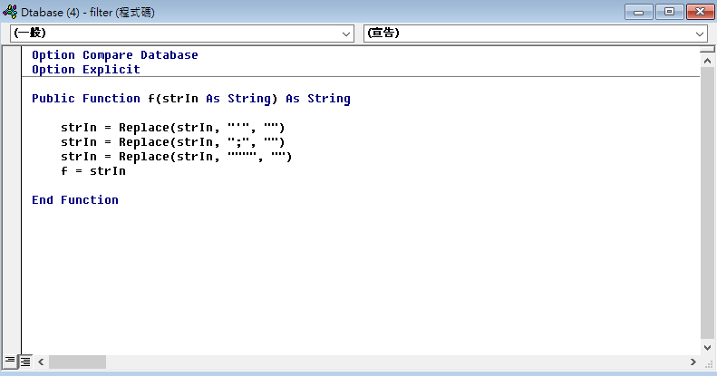

# User interface and Form design

The user interface and the form designs shown as above:

## For Business Partners

### The user interface for business partners.

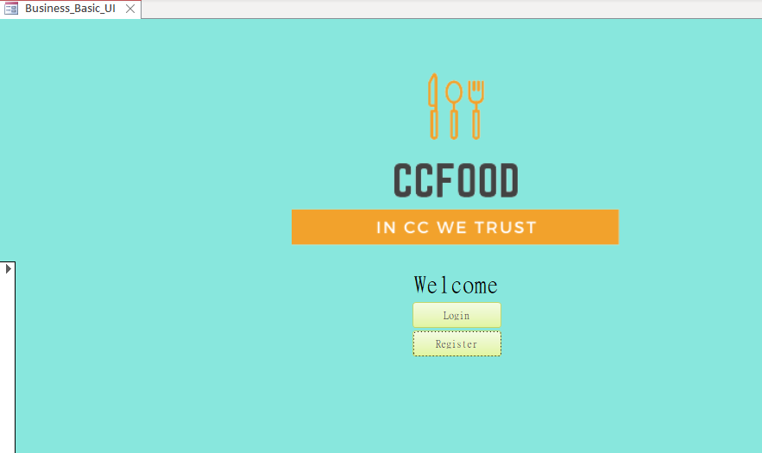

### The login screen for business partners

If the Login button are selected, the login form will be shown.

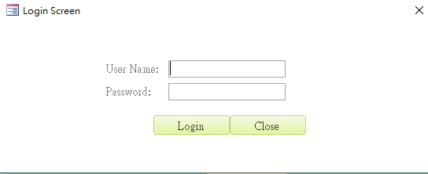

After user input their user name and password, they can click the Login button to login.

The close button is for user to close the form.

### The Business Registration Form

If the Register button are clicked, the business registration from will be shown.

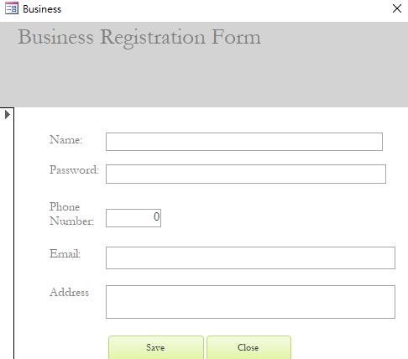

This form is or business registrant, input the Name, Password, Phone Number, Email, Address and click the save button to save their information to our database.

For changing the password, users only need to input their old password and new password. To prevent users from entering the wrong password, user need to input the password twice.

### Password Change Screen

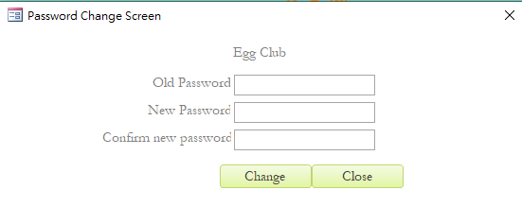

### Interface for Business modify record

This is the interface for Business modify their record, there are four buttons below, user can delete, save change password or redo by selecting these buttons.

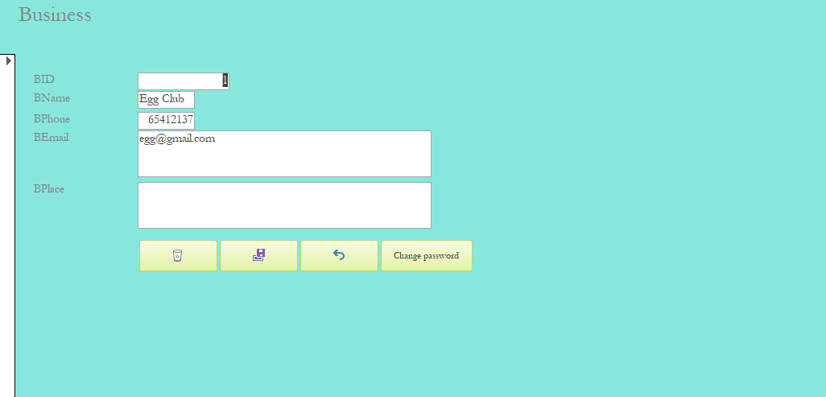

### Interface after login

This is the user interface for Business Partners after login:

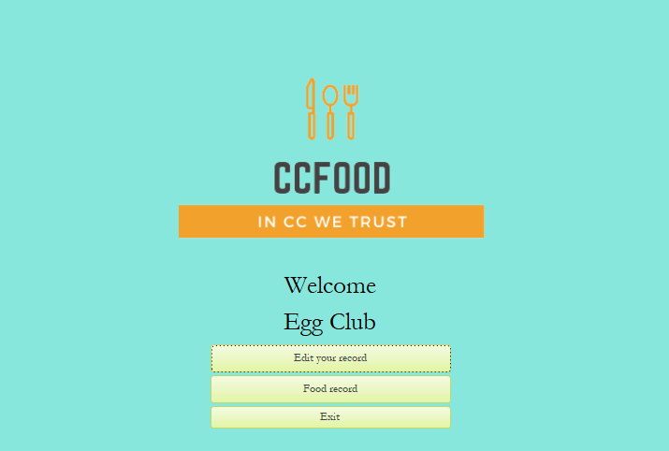

There three button in this user interface: Edit your record, Food record and Exit.

When Edit your record button are clicked,the form of modify record for business partner will be shown.

When Food record button are clicked,the food record of that business partner will be shown.

When the exit record are clicked, user will return to the previous screen

After exit button clicked:

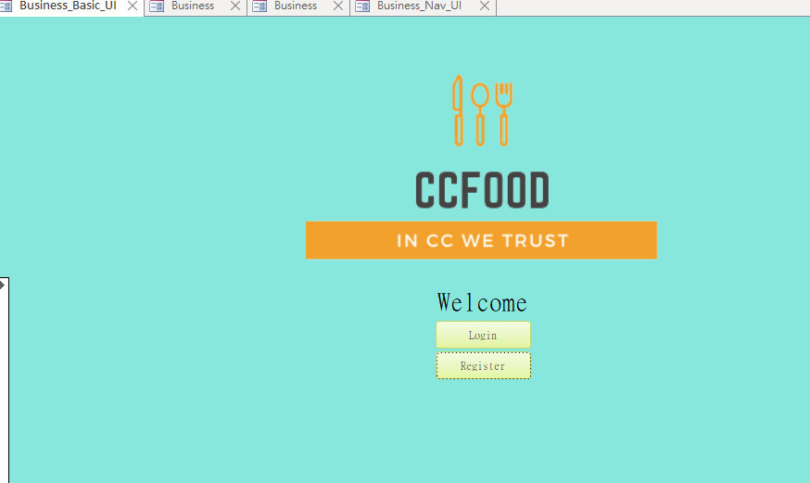

## For Clients

### Interface for clients

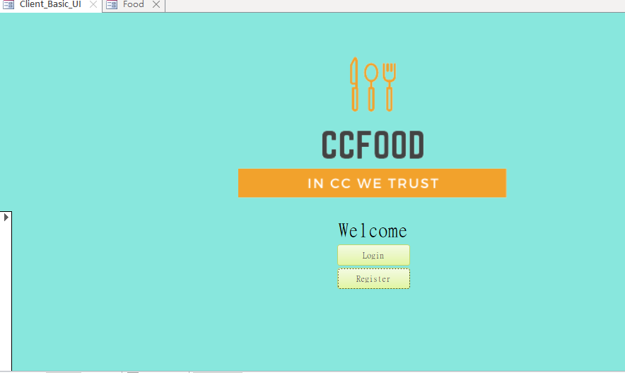

The interface look like as same as the interface of business.

The button Login and Close‘s function are same with the button in the login screen of business partner, but the data of client will be stored at database of client.

### Login screen for client

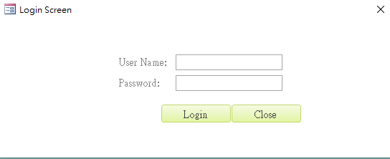

### Form for client edit data

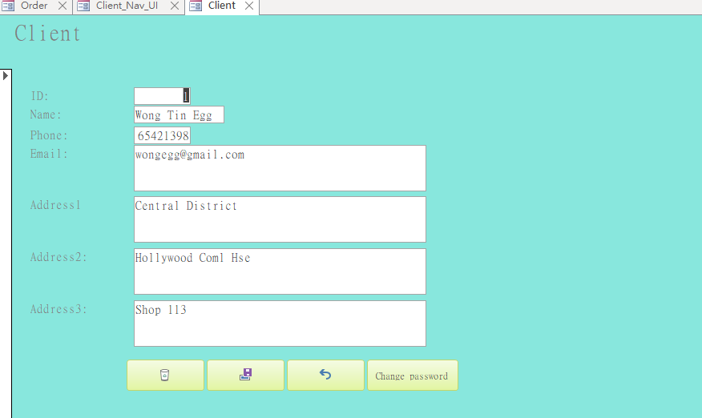

This is the interface for client modify their record, there are four buttons below, user can delete, save change password or redo by selecting these buttons. As same as the Form for business partner edit their data.

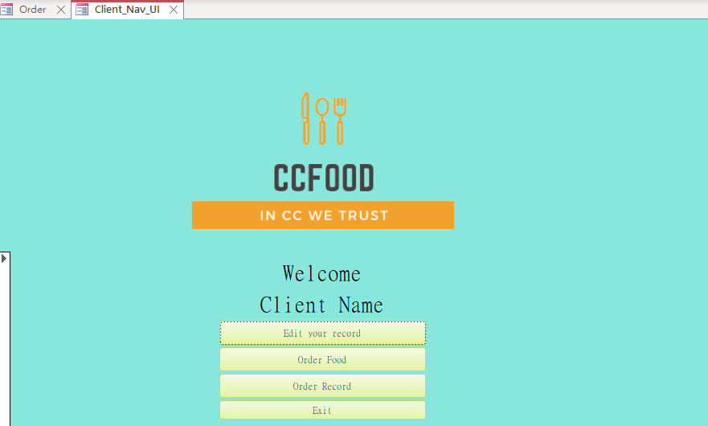

### Form for order food

This is the form for client to order food. Clients can click the button clicked to choose food they want.

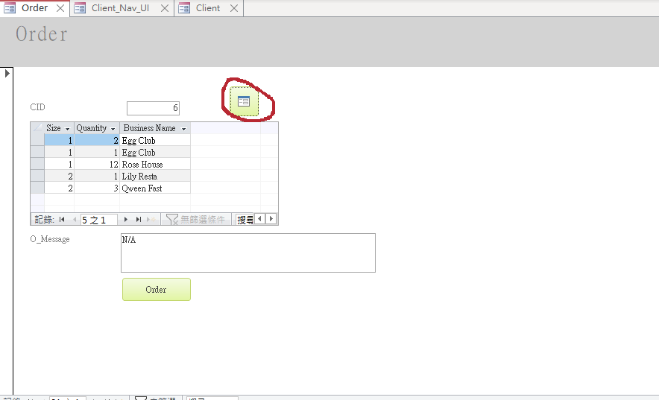

After the button are clicked, the menu are shown(shown in the picture below)client can see the data of different food such as Food Name, Type,Size,Price,taurant Name and the picture of food in the form. These data are locked to avoid that client change these data mistakenly. User can input the quantity and click add to car to order food.

## For Staff

### Basic UI for Staff

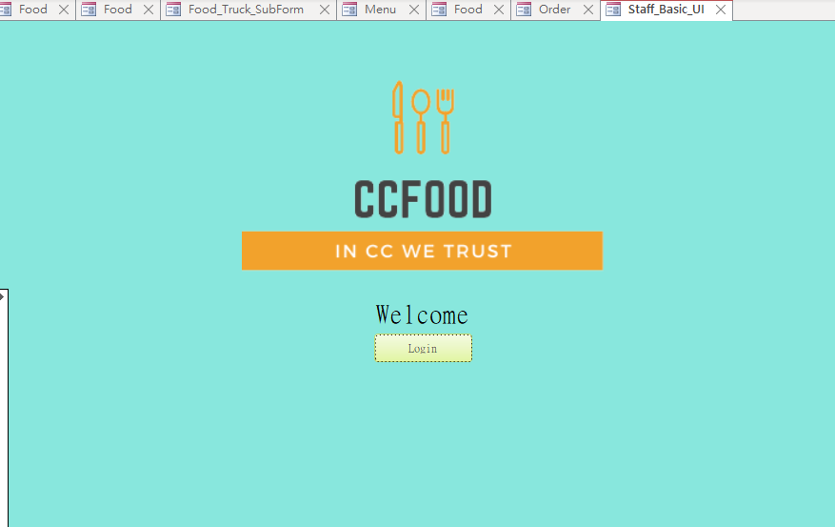This is the basic user interface for staff, after login button are clicked, the login screen will be shown, just like the business and client interface.

The button Login and Close‘s function are same with the button in the login screen of business partner, but the data of staff will be stored at database of staff.

### Login Screen For Staff

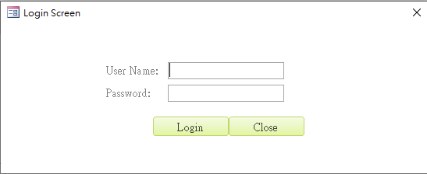

### Password Changing Form

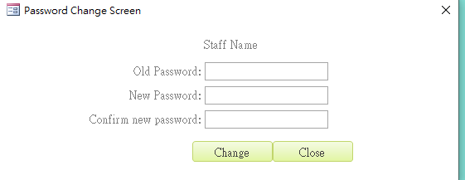

### Staff Registration Form

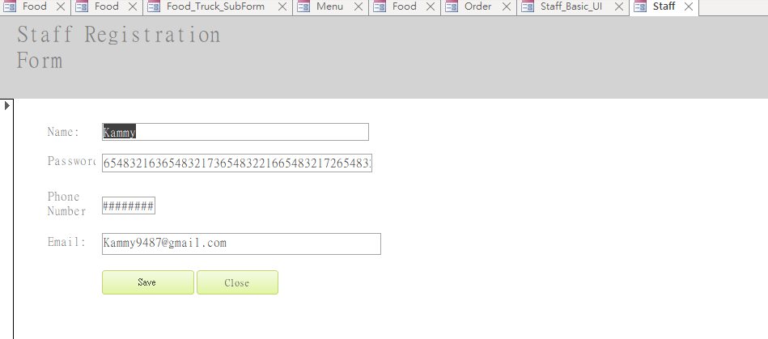

### Interface for staff after login

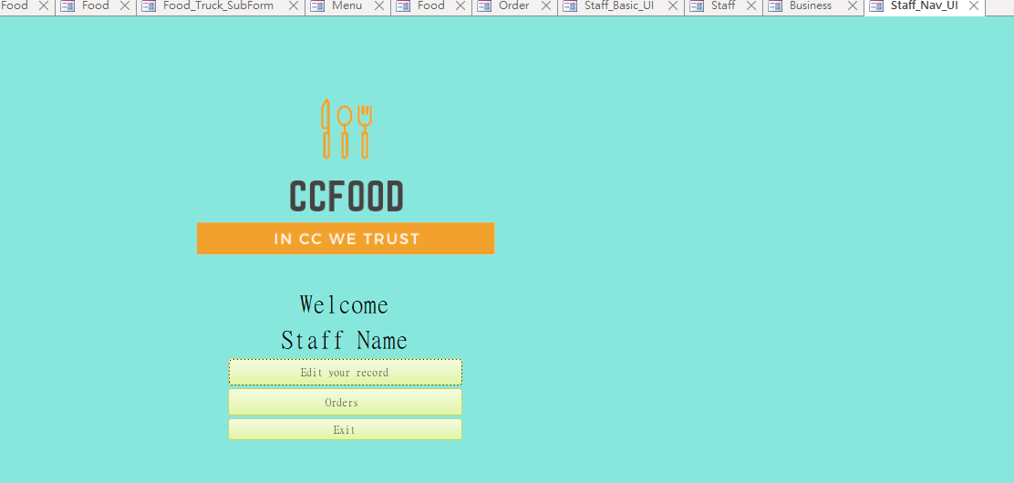

### Form for staff to edit their data

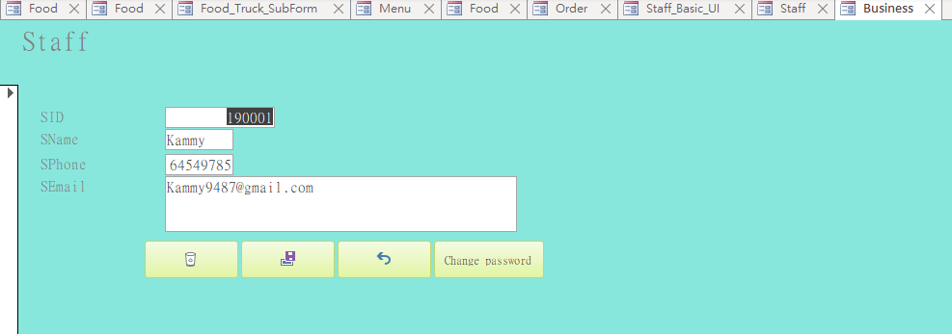

# VBA

## VBA for Business

This VBA is for Business users to change their password by alter database record after checking is the input value match system record or not.

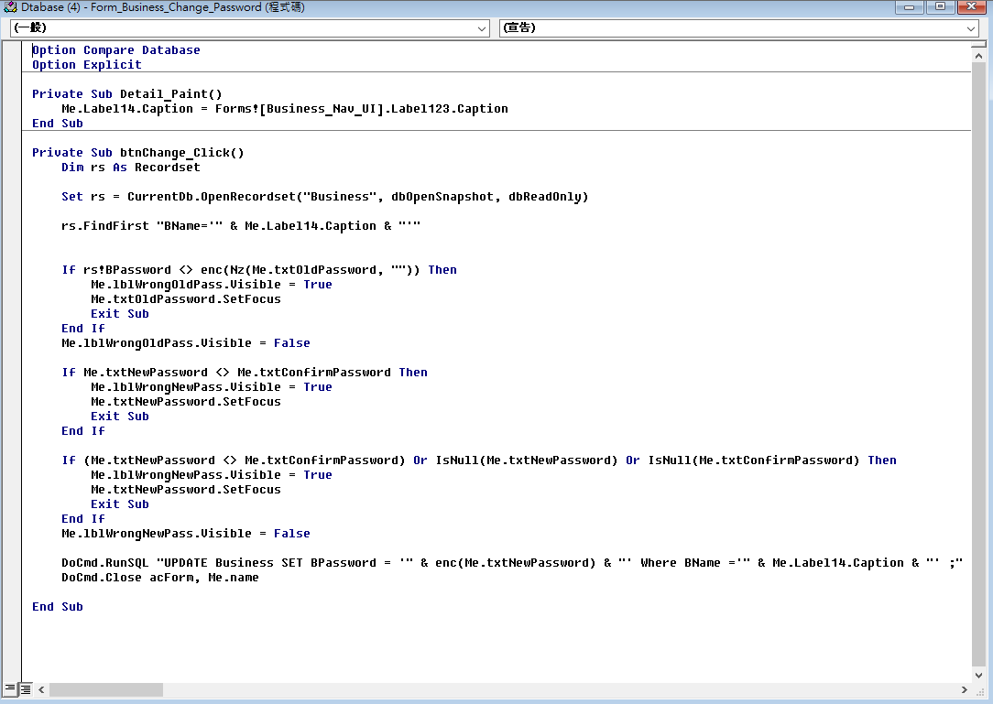

This VBA is for Business users to input the data into the database after filtering bad words.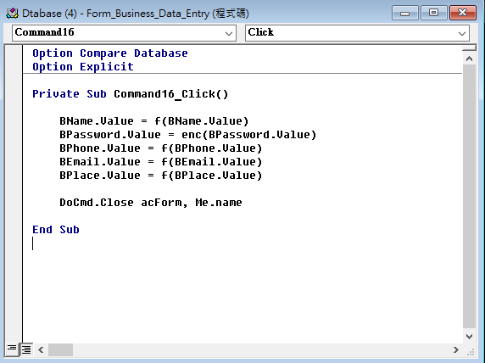

This VBA is for Business users to login after checking is the input value match system record or not.

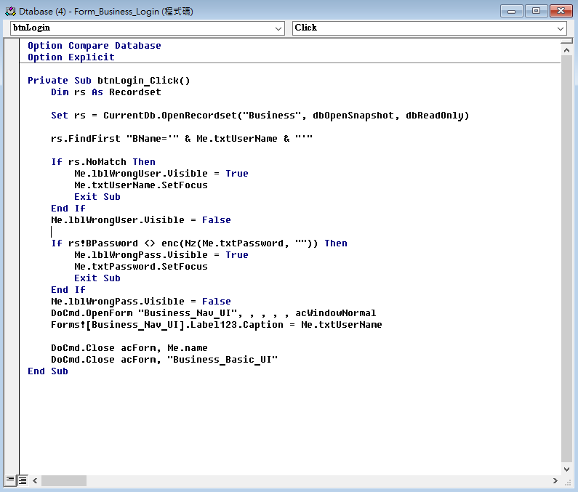

This VBA is for Business users to modify their record.

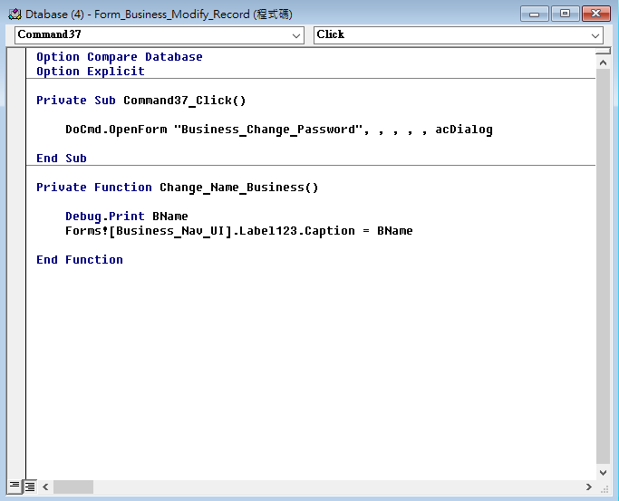

This VBA is for navigating Business users to their own interface after login.

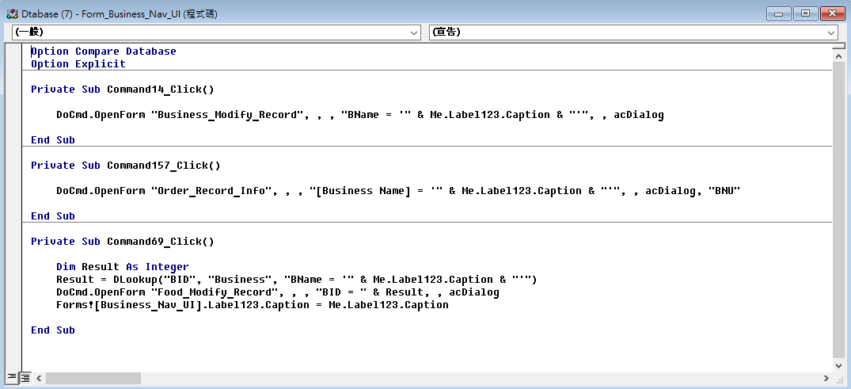

## VBA for Client

This VBA is for Client to change their password by alter database record after checking is the input value match system record or not.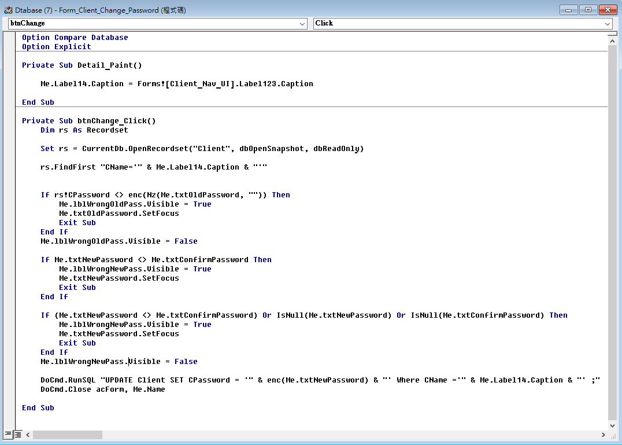

This VBA is for Client users to input the data into the database after filtering bad words. same as the VBA for Business users to entry data, but this is for Client.

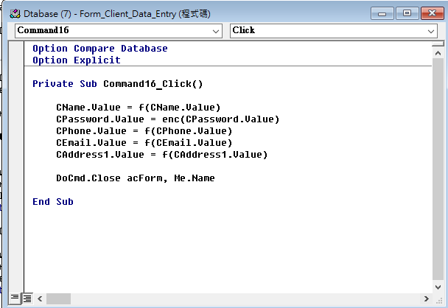

This VBA is for Client to login after checking is the input value match system record or not.

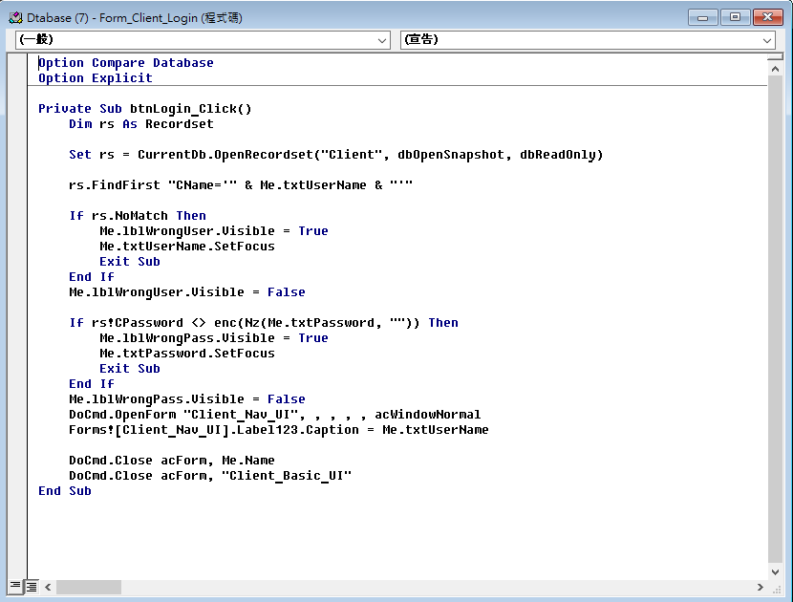

This VBA is for Client users to modify their record.

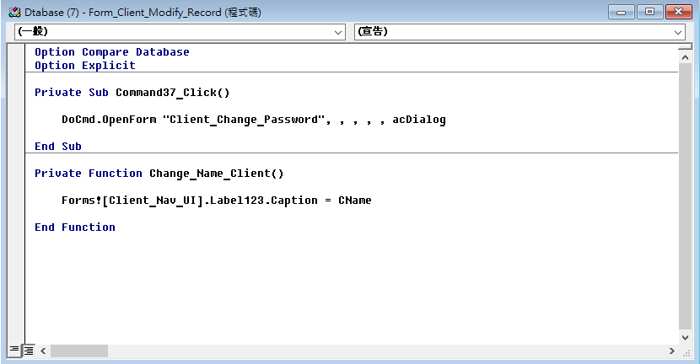

This VBA is for navigating Client users to their own interface after login.

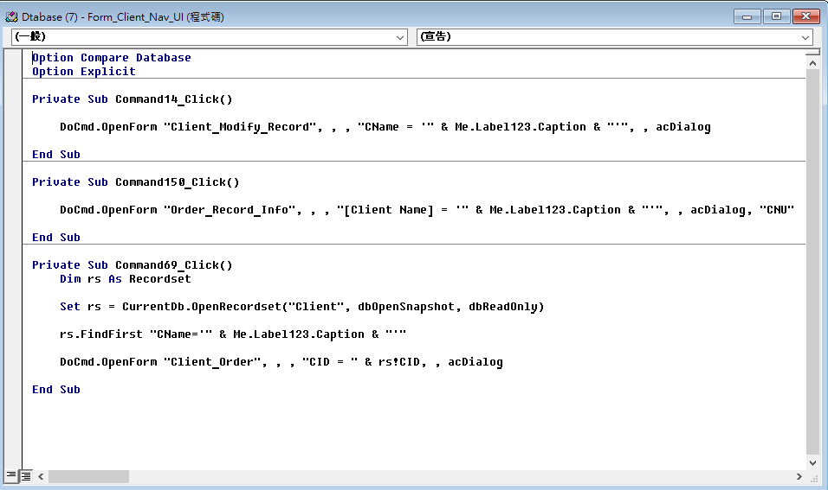

This VBA is for Client users to input their order. After clients order their food, it will find the matches record of order and move it from Food_Truck to Order_Food.

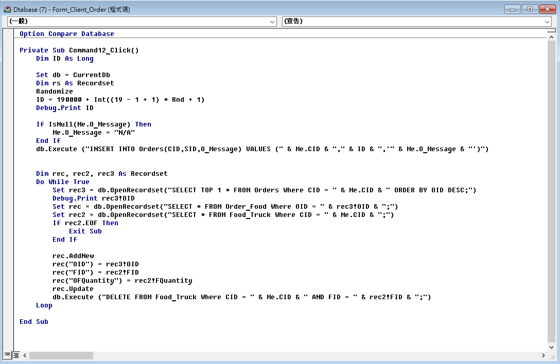

This VBA is for the menu. It provides a user interface for Client User to select the foods to order, provides two search functions filtering by Food Type of Restaurant Name, and also provides a clear function to clear the filter.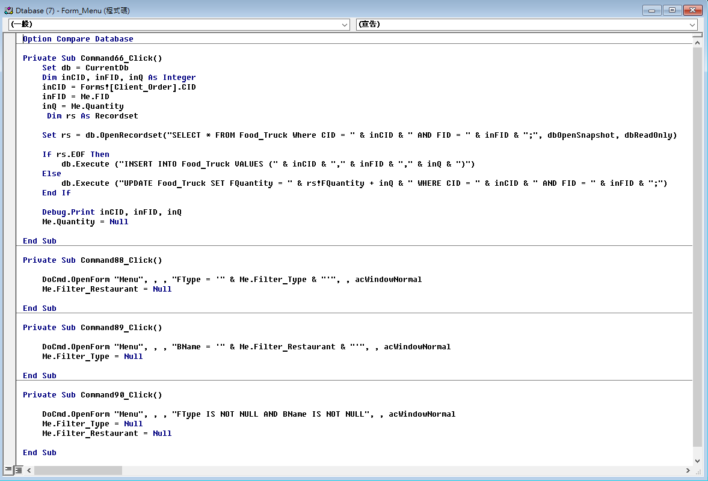

This VBA is for the form Order_Record_Info, each type of user (business, staff, client) can tick different boxes by the confirm button to confirm the process of the takeaway.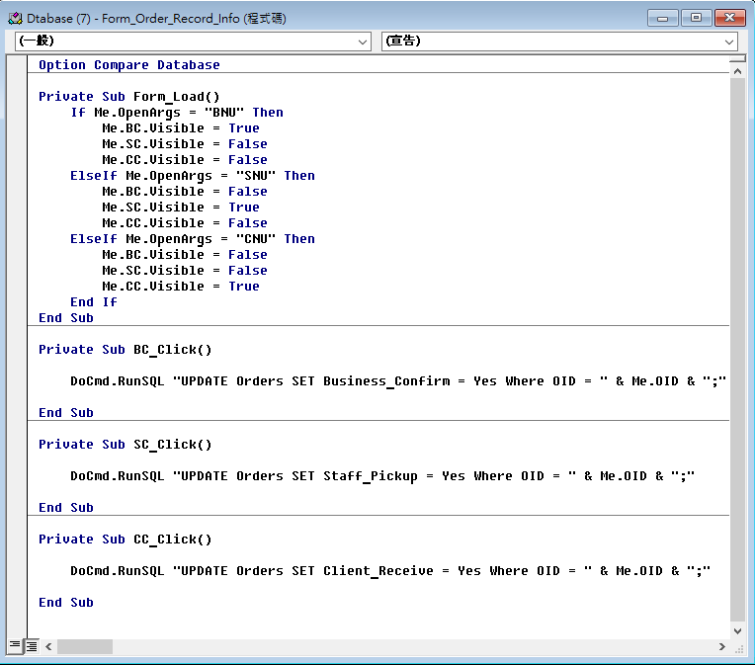

This VBA is for staff to change their password by alter database record after checking is the input value match system record or not.

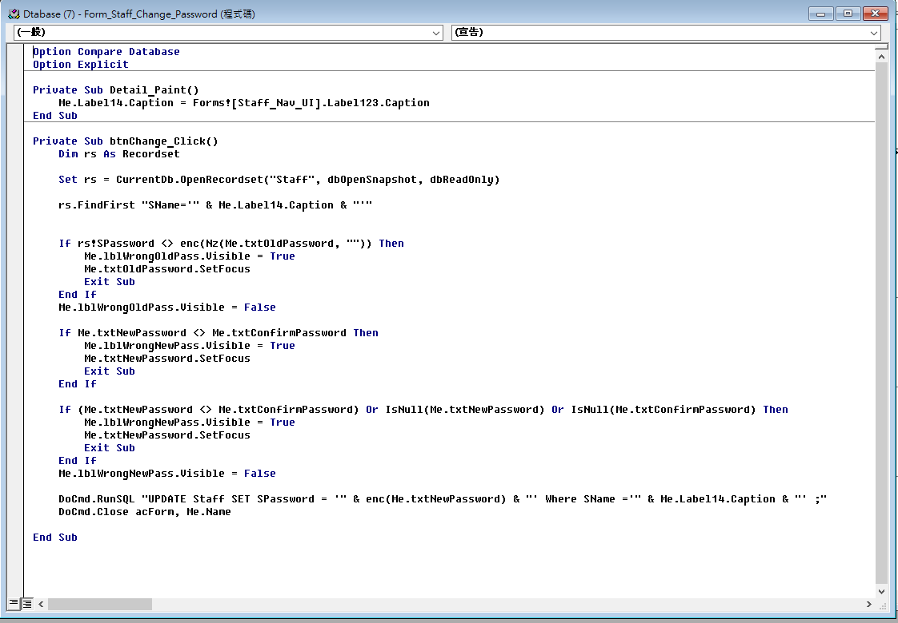

This VBA is for staff entry their data.

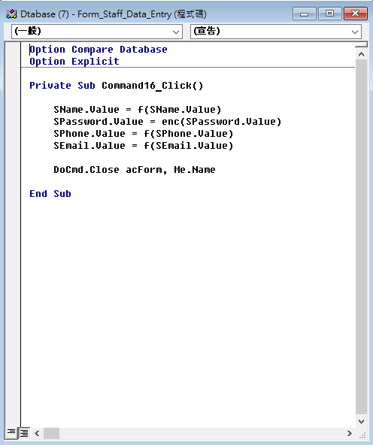

This VBA is for staff to login after checking is the input value match system record or not.

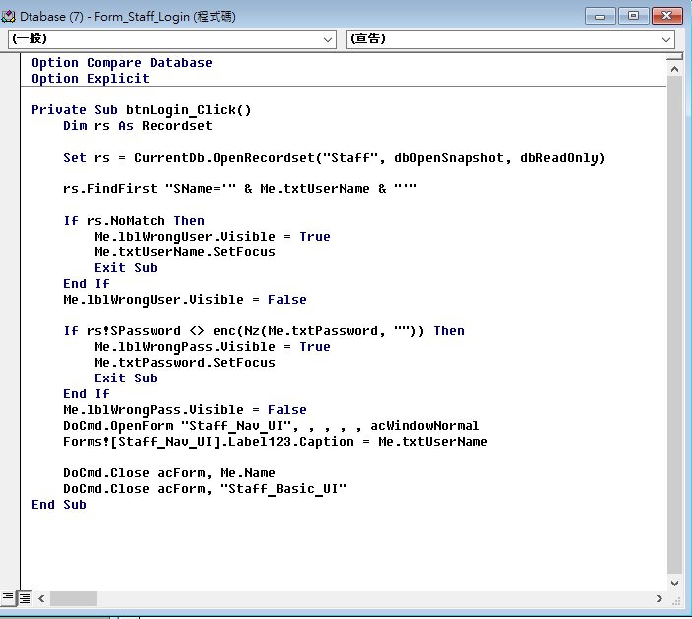

This VBA is for staff to modify their record.

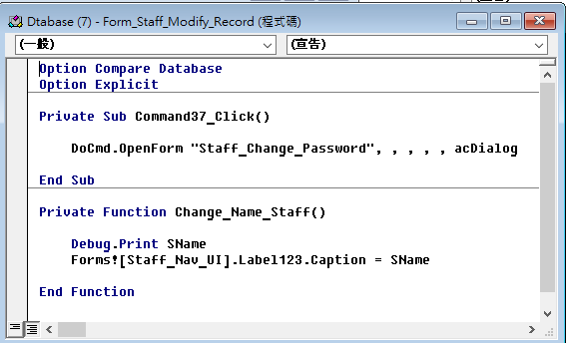

This VBA is for navigating Staff to their own interface after login.

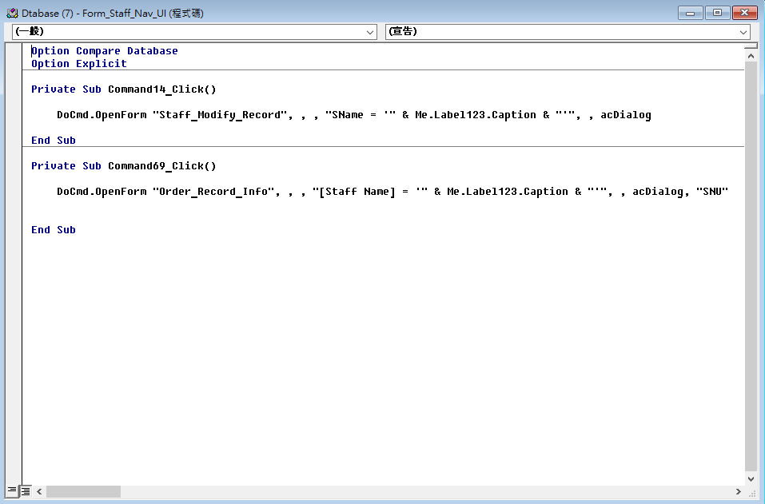

## For all of the users

### Menu

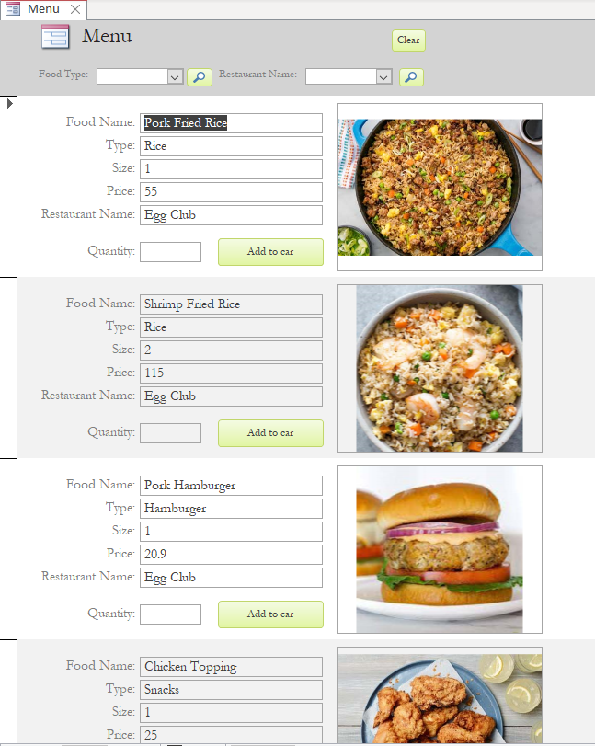

Also, our platform has so many kinds of food. or the convenience of our customers, we add a search function. Y can select the food type you want by clicking the arrow next to Food Type. for example, user can select a specific type of food such as hamburger. After the button with magnifying glass clicked, the form will only show the food of hamburger.

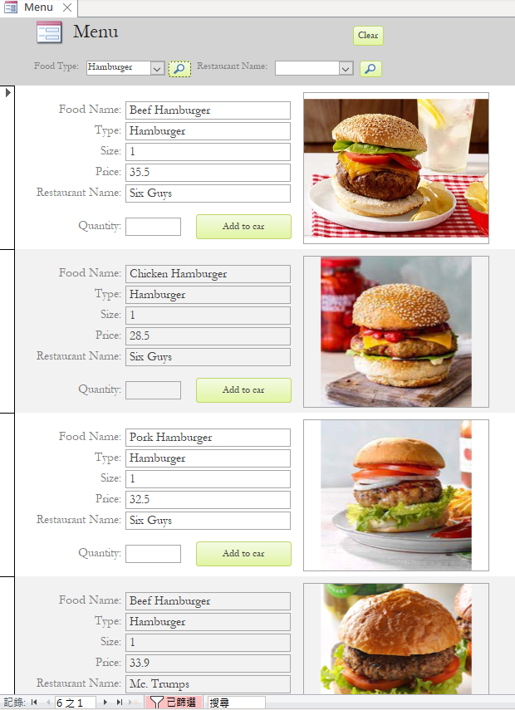

Also, user can search their favorite restaurant too. for example, our user only wants to eat the food from egg club (or other restaurant), they can select and the food from that restaurant will only be shown in menu.

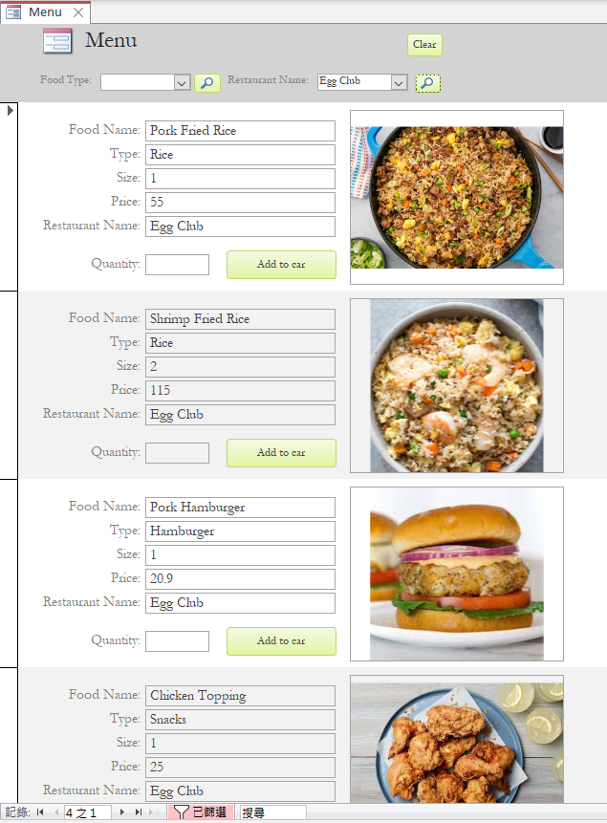

After the food are selected, Order Form will record the food you ordered let you have a chance to change your mind or check that is there any food you misclicked. Also, you can type any specific requirement you want (such as less sugar, no salt, extra tissue, etc) in the box of O_Message. After client check that there no mistake, they can click the order button.

#### Order

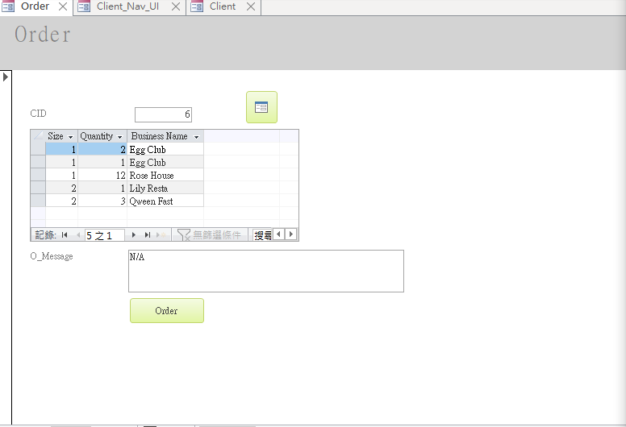

#### Food

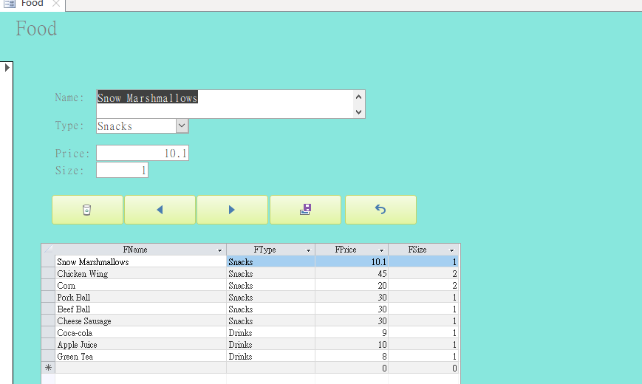

#### Food record

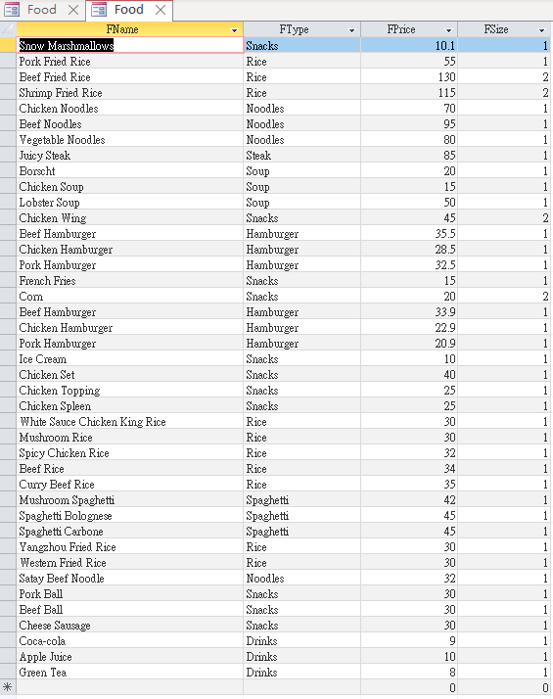

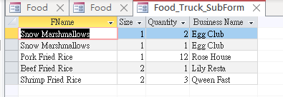

#### Order info

This is the form for record the order info, such as client name, food ordered, order message, the amount of food,restaurant and client’s address.our staff can delivery the right food to the right place by following this form’s data. By clicking the 2 button under order message, staff can change the data shown to the previous or next order.

Before

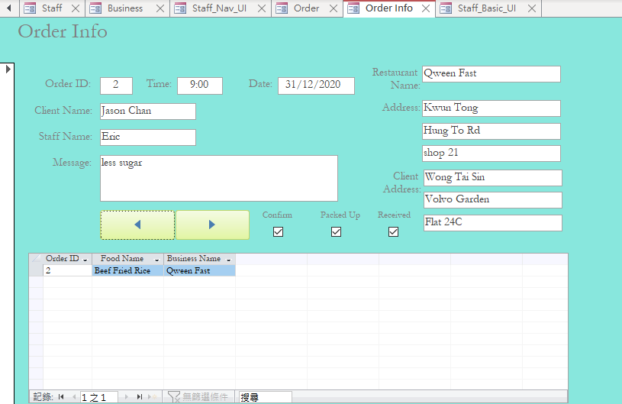

After

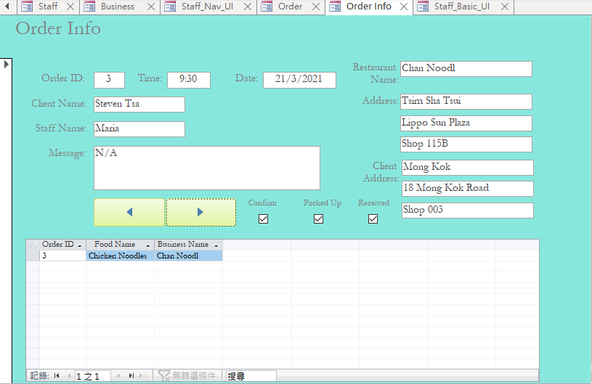

It clearly shows that when the right arrow button are clicked, the order id changed and the data of the form became another order.

This is the form of order that record the order of each staff deliver.

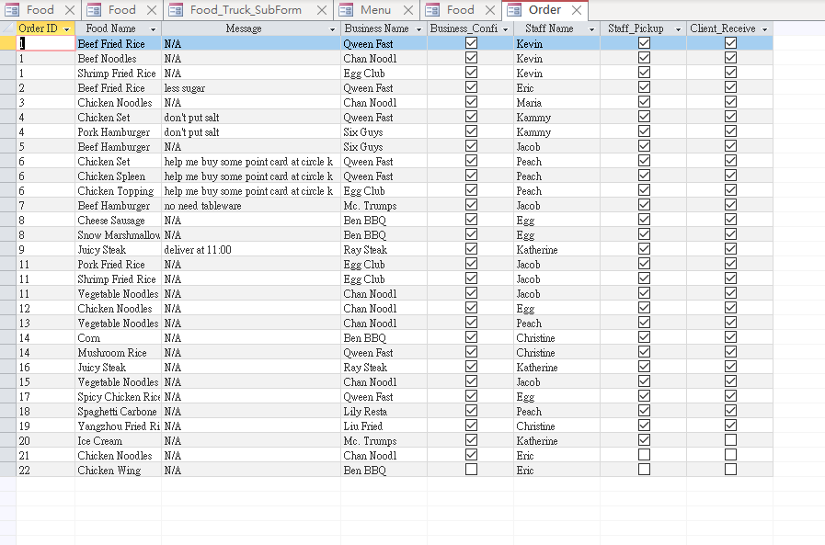

# Report design

## Food_Rank_In_Total_Report:

This report shows the quantity of each food and there price and ordered by the quantity.

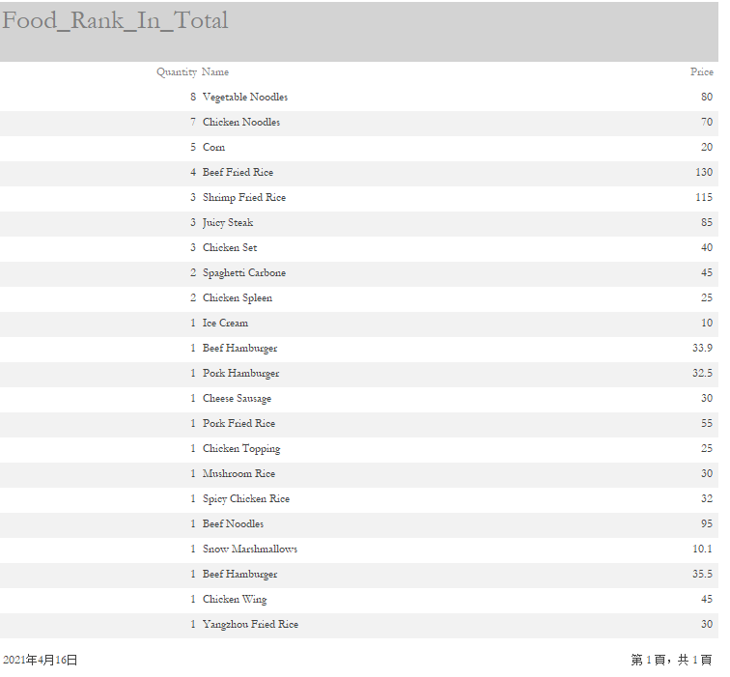

## Money_Flow_In_Total_Report

This report displays the amount each food sold and the money flow.

The two boxes under the column Quantity and Total Flow show out the amount of food sold out and the total flow specifically. 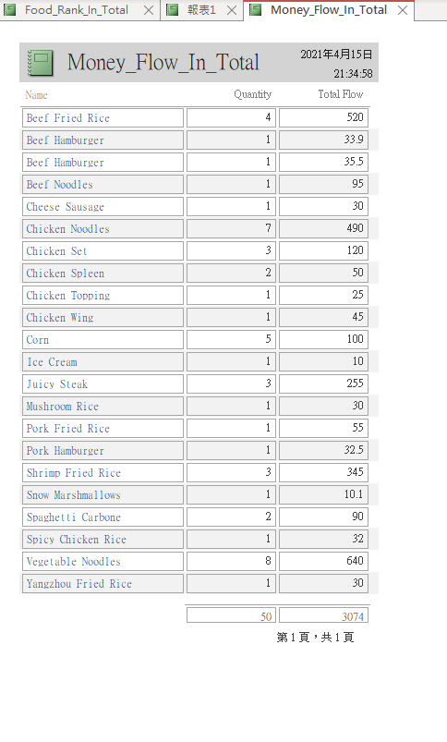

## Food_Rank_In_Total Report (By Type)

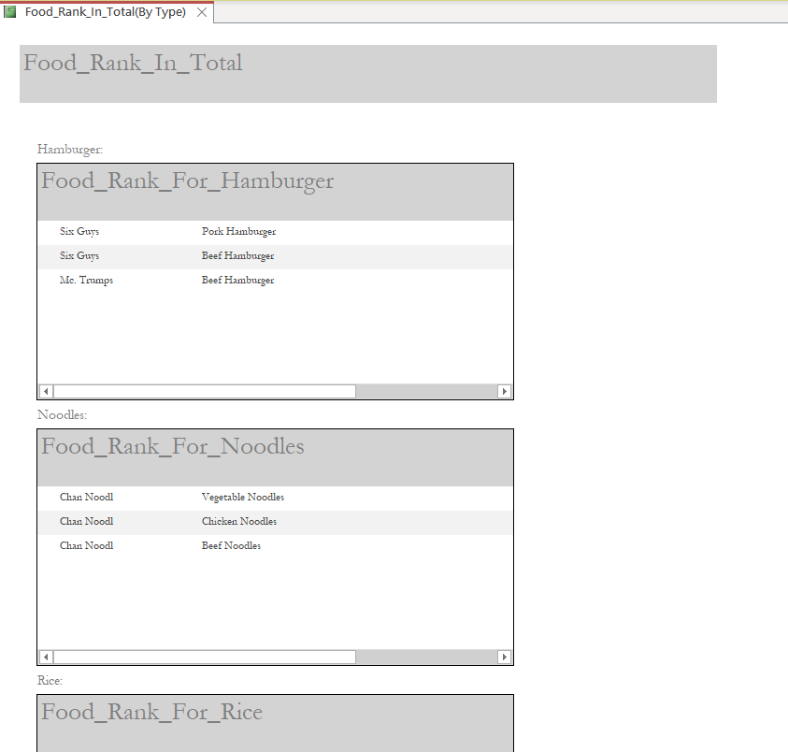

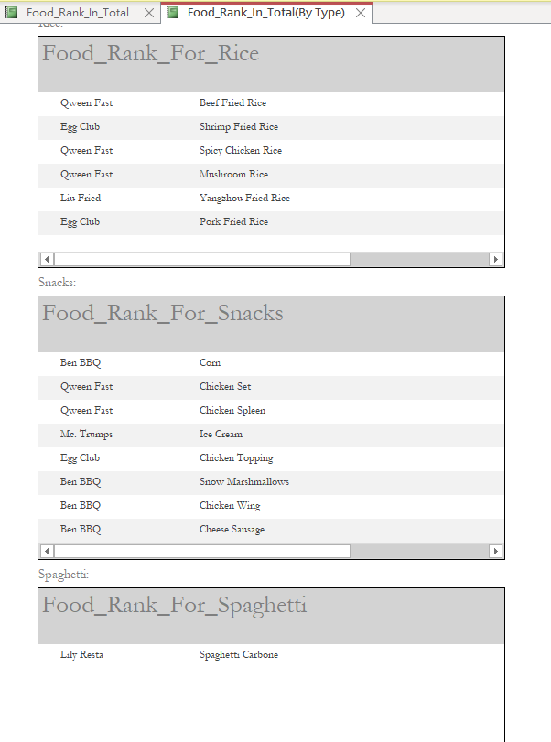

This report shows out the food rank and classification by species,Business partner can use this table to determine their market share of a food item on our platform.

## Business_Rank_In_Total

This report shows out the business rank in total.Business partner can see this report after then login our platform as a business partner.For different BuninessName,they can see how many percentage he have in out platform.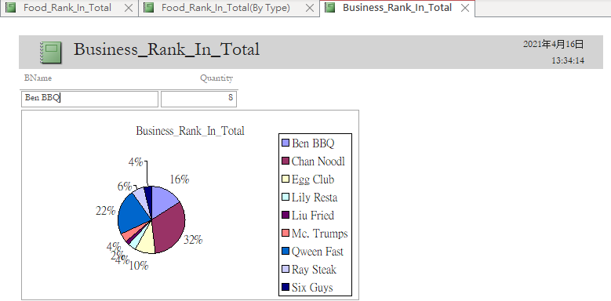

## Food_Rank_For_Specific_Food

This is the report of food rank of hamburger.

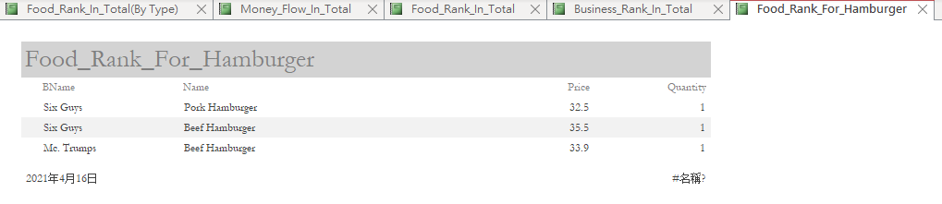

This is the report of food rank of noodle.

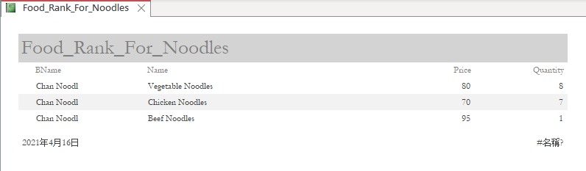

This is the report of food rank of rice.

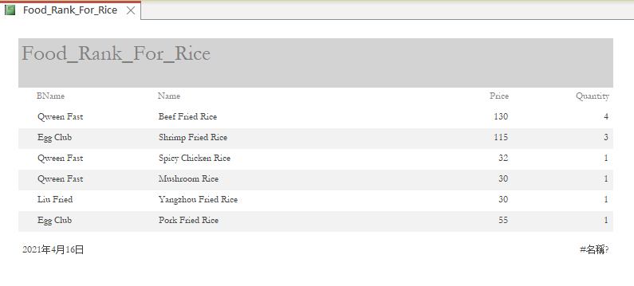

This is the report of food rank of snacks.

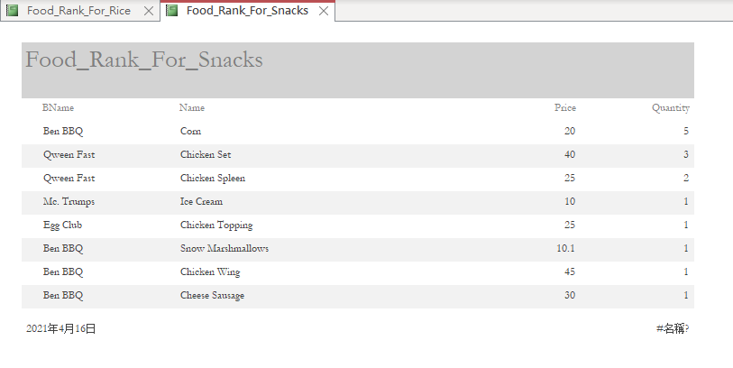

This is the report of food rank of spaghetti.

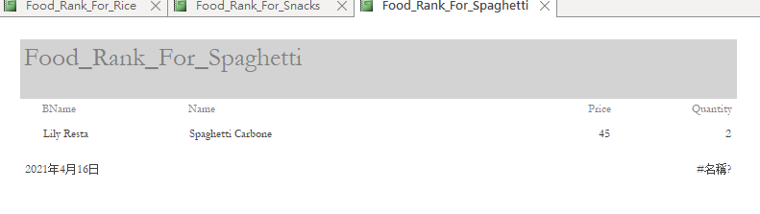

# Work Distribution List

|  |  |  |  |
| --- | --- | --- | --- |
| Task | Start Date | Finish Date | Responsible |
| Outline | 10/03/2021 | 11/03/2021 | All |
| Adding Data | 01/04/2021 | 10/04/2021 | All |
| Design Form | 08/04/2021 | 11/04/2021 | Wong Tin Yau |
| Design Query | 08/04/2021 | 11/04/2021 | Wong Tin Yau |
| Making SQL | 08/04/2021 | 11/04/2021 | Kwok Chun Wing  Wong Tin Yau |
| Word Report | 01/04/2021 | 13/04/2021 | Cho Shing Yin  Kwok Chun Wing  Wong Cho Hin |
| PowerPoint | 01/04/2021 | 14/04/2021 | Cho Shing Yin  Wong Cho Hin |
| Debug | 09/04/2021 | 15/04/2021 | All |

# Conclusion

During designing this database, we encountered many difficulties, such as the normalization, resolve M: N relationship. We put lots of effort and research to solve the problem. Finally, we use energy and persistence to conquer all things. We also learnt that building a small database also consume a lot of time. We need to think how to design tables and how to make a report or a query to present the data clearly.

While designing the database, we gained a better understanding of how a food delivery platform works. We need to care the needs of business partners, customers and our staffs. We have to think about their actual use when designing the UI, forms and queries.

All in all, we gained a lot while making this platform. Although there are still spaces for improvement, it is hoped that this food delivery platform can really provide convenience for users in daily life.

# Reference

<https://www.foodnetwork.com/> (Food Photos)

<https://stackoverflow.com/>

<https://www.youtube.com/>